**Supplementary Information**

# Size-based characterization of adalimumab and TNF-α interactions using Flow Induced Dispersion Analysis: Assessment of Avidity-stabilized Multiple Bound Species

Morten E. Pedersen†,a,b, Ragna M.S. Haegebaert†,b, Jesper Østergaardb, and Henrik Jensena,b

*aFida Biosystems ApS, Fruebjergvej 3, 2100 Copenhagen Ø, Denmark.*

*bDepartment of Pharmacy, University of Copenhagen, Universitetsparken 2, 2100 Copenhagen O, Denmark.*

† *These authors contributed equally*

**Raw data for establising the binding curve**

In figure S1 an overlay of normalized raw data used to obtain Figure 2 is shown. The figure clearly shows the peak broardening in response to binding. In order to facilitate comparison, the data were normalized to the retention time as described in the literatureS1.

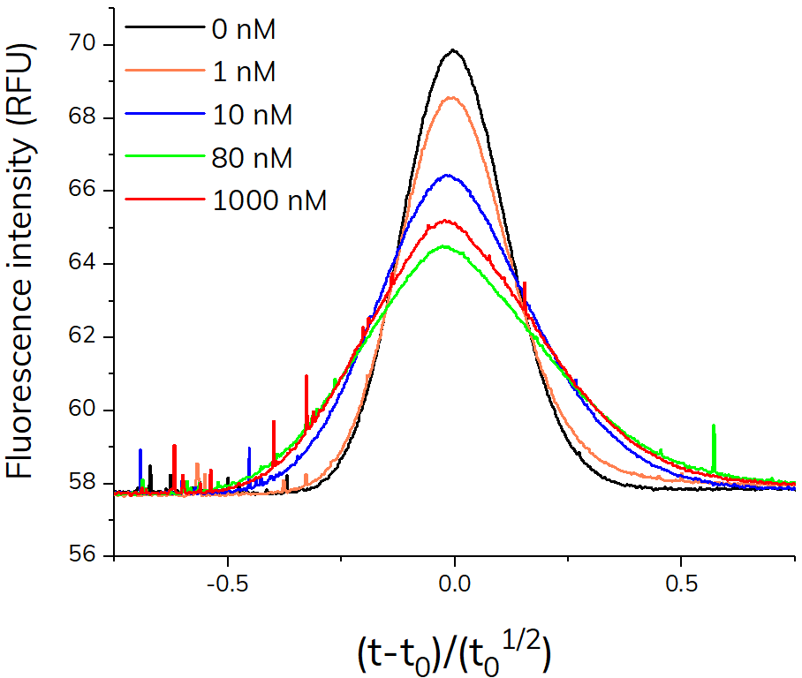

*Figure S1: Normalized raw data (i.e., Taylorgrams) of TNF-α-alexa488 in presence of increasing concentrations of adalimumab used to obtain the binding curve in Figure 2 in the main manuscript.*

**Extended binding model**

In this work, we assume the presence of only 1:1, 1:2, 2:1 and 2:2 (TNF-α - adalimumab) binding stoichiometries described by the following equilibria:

$TA⇌ T+A$ (S1)

$T_{2}A⇌ TA+T$ (S2)

$TA_{2}⇌ TA+A$ (S3)

$(T{A)}_{2}⇌ TA+TA$ (S4)

$(T{A)}_{2}{⇌T}_{2}A+A$ (S5)

$(T{A)}_{2}⇌TA_{2}+T$ (S6)

where T is the indicator (i.e. TNF-α in the present work) and A is the analyte (adalimumab in the present work). TA, TA2, T2A and (TA)2 are the 1:1, 1:2, 2:1 and 2:2 complexes formed from TNF-α and adalimumab, respectively. These complexes have previously been described in the literatureS2-S3.

The dissociation constants (*K*d) corresponding to S1-S6 can be written as:

$K_{d_{1}}=\frac{\left[T\right] ∙ [A]}{[TA]}$ (S7)

$K_{d_{2}}=\frac{[TA]∙ [T] }{[T_{2}A]}$ (S8)

$K_{d_{3}}=\frac{\left[TA\right] ∙ [A]}{[TA_{2}]}$ (S9)

$K_{d_{4}}=\frac{{\left[TA\right]}^{2} }{[{(TA)}_{2}]}$ (S10)

$K_{d_{5}}=\frac{[T_{2}A] ∙ [A]}{[{(TA)}_{2}]}$ (S11)

$K_{d_{6}}=\frac{[TA_{2}] ∙ [T]}{[{(TA)}_{2}]}$ (S12)

where [T], [A], [TA], [TA2], and [(TA)2]are the actual TNF-α, adalimumab, 1:1 complex, 1:2 complex, 2:1 complex and 2:2 complex concentrations, respectively.

The formal concentration of T (*CT*) can be written as:

+ 2 · [ $T_{2}A]$ (S13)

The formal concentration of A (*C*A) can be written as:

+ [ (S14)

From which the actual adalimumab concentration is obtained as

$\left[A\right]=C_{A}-\left(\left[TA\right]+2∙\left[TA_{2}\right]+2∙[{\left(TA\right)}_{2}] + [T_{2}A]\right)$ (S15)

The actual concentrations of the T containing species can be expressed according to the concentration of T by employing equation S1-S3:

$\left[TA\right]=\frac{\left[T\right] ∙ [A]}{K_{d_{1}}}$ (S16)

$\left[TA_{2}\right]=\frac{\left[T\right] ∙{\left[A\right]}^{2}}{K_{d_{1}}∙K_{d_{3}}}$ (S17)

[ $T_{2}A]= \frac{\left[A\right] ∙{\left[T\right]}^{2}}{K_{d_{1}}∙K_{d_{2}}}$ (S18)

The concentration of ${\left(TA\right)}_{2}$ is determined by S4 – S6. In order to take into account all three dissociation pathways the equilibria are summed up to give the following expression for the total dissociation:

$K_{d_{4}}∙K_{d_{5}}∙K_{d_{6}}= \frac{[T_{2}A] ∙ [A]}{[{(TA)}_{2}]}∙\frac{{\left[TA\right]}^{2} }{[{(TA)}_{2}]}∙\frac{[TA_{2}] ∙ [T]}{[{(TA)}_{2}]}$ (S19)

${[{(TA)}_{2}]}^{3}=\frac{{\left[T\right]}^{2}∙{\left[A\right]}^{2} }{{K_{d_{1}}}^{2}∙K_{d_{4}}∙K_{d_{5}}}∙\frac{{\left[A\right]}^{2} ∙{\left[T\right]}^{2}}{K_{d_{1}}∙K_{d_{2}}∙K_{d_{6}}}∙\frac{{\left[T\right]}^{2}∙{\left[A\right]}^{2} }{K_{d_{1}}∙K_{d_{3}}}$ (S20)

$[{(TA)}_{2}]$ = $\frac{{\left[T\right]}^{2}∙{\left[A\right]}^{2} }{\sqrt[3]{{K_{d_{1}}}^{4}∙K_{d_{4}}∙K_{d_{5}}∙{K_{d_{6}}∙K_{d_{3}}∙K}_{d_{2}}}}$ (S21)

According to S1-S6 the complete dissociation of (TA)2 can follow three distinct pathways all resulting in the complete dissociation into T and A. The thermodynamic consequence is that:

${K_{d_{1}}}^{2}∙K_{d_{4}}=K_{d_{1}}∙{K_{d_{2}}∙K_{d_{5}}=K_{d_{1}}∙K}_{d_{3}}∙K_{d_{6}}$ (S22)

Further, based on the chemical composition of the formed complexes we shall simplify the model assuming that $K_{d_{4}}= K_{d_{5}}=K_{d_{6}}$ and $K_{d_{1}}=K_{d_{2}}= K_{d_{3}}$.

Under this assumption S21 reduces to:

$[{(TA)}_{2}]$ = ${\left[T\right]}^{2}∙$ $\frac{{\left[A\right]}^{2} }{{K_{d_{1}}}^{2}∙K_{d_{4}}}$ (S23)

Substituting S16-S18 and S23 into S13 yields:

$C_{T}=\left[T\right]+\frac{\left[T\right] ∙ [A]}{K_{d_{1}}}+\frac{\left[T\right] ∙{\left[A\right]}^{2}}{K_{d_{1}}∙K_{d_{3}}}+2∙\frac{{\left[T\right]}^{2}∙{\left[A\right]}^{2}}{K_{d_{1}}^{2}∙K_{d_{4}}}+2∙\frac{\left[A\right] ∙{\left[T\right]}^{2}}{K_{d_{1}}∙K_{d_{2}}}$ (S24)

Rearranging eq S21 results to the following second order equation provides:

${{\left[T\right]}^{2}\left(2∙\frac{{\left[A\right]}^{2}}{K_{d_{1}}^{2}∙K_{d_{4}}}+2∙\frac{\left[A\right] }{K_{d_{1}}∙K_{d_{2}}}\right)+\left[T\right]\left(1+\frac{[A]}{K_{d_{1}}}+\frac{{\left[A\right]}^{2}}{K_{d_{1}}∙K_{d_{3}}}\right)-C}_{T}=0$ (S25)

Defining

$A_{T}=2∙\frac{{\left[A\right]}^{2}}{K_{d_{1}}^{2}∙K_{d_{4}}}+2∙\frac{\left[A\right] }{K_{d_{1}}∙K_{d_{2}}}$ (S26)

$B_{T}=1+\frac{[A]}{K_{d_{1}}}+\frac{{\left[A\right]}^{2}}{K_{d_{1}}∙K_{d_{3}}}$ (S27)

equation S22 can then be written as:

${{\left[T\right]}^{2}{∙A}_{T}+\left[T\right]∙B_{T}-C}_{T}=0$ (S28)

Equation S25 has the following chemically meaningful closed form solution:

$\left[T\right]=\frac{-B_{T} +\sqrt{B_{T}^{2} + 4∙A_{T}{∙C}_{T}}}{2∙A_{T}}$ (S29)

Following a similar strategy for [TA], ${ C}_{T}$ can be linked to [TA] according to:

${{\left[TA\right]}^{2}\left(2∙\sqrt[3]{\frac{{K_{d_{1}}}^{2}}{K_{d_{2}}∙K_{d_{3}}∙K_{d_{4}}∙K_{d_{5}}K_{d_{6}}}}+2∙\frac{K_{d_{1}} }{\left[A\right]∙K_{d_{2}}}\right)+\left[TA\right]\left(1+\frac{K_{d_{1}}}{[A]}+\frac{\left[A\right]}{K_{d_{3}}}\right)-C}_{T}=0$ (S30)

Assuming as before that $K_{d_{4}}= K_{d_{5}}=K_{d_{6}}$ and $K_{d_{1}}=K_{d_{2}}=K_{d_{3}}$ equation S30 reduces to:

${{\left[TA\right]}^{2}\left(2∙\frac{1}{K_{d_{4}}}+2∙\frac{K_{d_{1}} }{\left[A\right]∙K_{d_{2}}}\right)+\left[TA\right]\left(1+\frac{K_{d_{1}}}{[A]}+\frac{\left[A\right]}{K_{d_{3}}}\right)-C}_{T}=0$ (S31)

Defining

$A_{TA} = 2∙\frac{1}{K_{d_{4}}}+2∙\frac{K_{d_{1}} }{\left[A\right]∙K_{d_{2}}}$ (S32)

$B_{TA}=1+\frac{K_{d_{1}}}{[A]}+\frac{{\left[A\right]}^{}}{K_{d_{3}}}$ (S33)

Equation S31 can be written:

${{\left[TA\right]}^{2}{∙A}_{TA}+\left[TA\right]∙B_{TA}-C}_{T}=0$ (S34)

Equation S34 has the following physically meaningful closed form solution:

$\left[TA\right]=\frac{-B_{TA} +\sqrt{B_{TA}^{2} + 4∙A_{TA}{∙C}_{T}}}{2∙A_{TA}}$ (S35)

The actual concentrations of $\left[TA_{2}\right]$ and [ $T_{2}A]$ are found from equations S8 and S9, and $[{\left(TA\right)}_{2}]$ is finally obtained from S13.

In cases where the concentration of T is very low compared to A, it is a good approximation to use $C_{A}$ in place of [A]. This is, however, not the case for the current set of data. The equation system is therefore simulated for a given set of *C*T and $K_{d_{1}}-K_{d_{6}}$ by using guesses of [A] to calculate concentrations of all the remaining species as listed above. An apparent concentration of *C*T is used in order to take into account dilution of T in the capillary. The “actual” [A] is calculated from equation S15 and finally the rooth mean square (rms) difference between “guessed” and “actual” [A] is obtained. For the present system, an evolutionary protocol is used and implemented in Excel using the solver package and the evolutionary solver tool. The optimization criterium is based on the sum of the rms difference of all the measured concentrations. Excel sheets are available upon request.

The actual measurement is an apparent hydrodynamic radius (*R*h) of the fluorescently labeled TNF-α. The apparent hydrodynamic radius is linked to an apparent diffusivity. For a simple 1:1 binding, it has previously been shown that the inverse of the measured apparent *R*h can be modeled as a weighted average of the inverse radius of the fraction bound and unboundS4. A similar model is used in the present case, where the relative fractions of the different species is calculated from the concentrations obtained as described above. The relative fractions of T, TA, TA2, and (TA)2are termed $x_{T}$, $x_{TA }, x_{{TA}_{2}}, x_{T_{2}A} and x_{{\left(TA\right)}_{2}} ,$ respectively.

$x_{T}=\frac{[T]}{C_{T}}$ (S36)

$x_{TA}=\frac{[TA]}{C_{T}}$ (S37)

$x_{T_{2}A}=\frac{[T_{2}A]}{C_{T}}$ (S38)

$x_{{TA}_{2}}=\frac{[{TA}_{2}]}{C_{T}}$ (S39)

$x_{{\left(TA\right)}_{2}}=\frac{[{\left(TA\right)}_{2}]}{C_{T}}$ (S40)

The measured apparent hydrodynamic radius (*R*h,app) is then obtained as:

$R_{h,app}= {\left(\frac{1}{R_{T}}{∙x}_{T}+\frac{1}{R_{TA}}{∙x}_{TA}+\frac{1}{R_{T_{2}A}}{∙x}_{T_{2}A}+\frac{1}{R_{{TA}_{2}}}∙x_{{TA}_{2}}+\frac{1}{R_{{\left(TA\right)}_{2}}}{∙x}_{{\left(TA\right)}_{2}}\right)}^{-1}$ (S41)

where $R_{T}, R_{TA}, R_{T_{2}A}, R_{{TA}_{2}} and R_{{\left(TA\right)}_{2}}$ are the hydrodynamic radii of T, TA, T2A TA2 and (TA)2, respectively.

The simulation is performed for different *C*T values as well as for different *K*d values and hydrodynamic radii in order to arrive at a simulation which represents the measured data well. The input parameters are manually optimised until an optimal fit to the data. The optimal *K*d´s are listed in the main manuscript. *C*T values of 12 nM and 5 nM were used to fit experimental dataset (figure 2A, 2B and 3) corresponding to 100 nM and 10 nM TNF- respectively. The lower *C*T takes into account capillary dilution effects. The simulation in figure 4 was performed using CT values of 0.22 pM, 10 nM and 100 nM, respectively.

**Steady-state concentration of adalimumab in RA patients**

Rheumatoid arthritis patients administered 40 mg every other week have a mean steady state serum concentration of 8 µg/mLS5. This corresponds to 54 nM, using a molecular weight of 148 kDa for adalimumabS5. Thus, the expected adalimumab concentration is 5.4 and 10.8 nM in 10 and 20 % v/v plasma, respectively.

**Endogenous TNF-α level**

The endogenous TNF-α serum level for healthy individuals has been reported as 11.2 ± 7.31 pg/mLS6, corresponding to 0.22 ± 0.14 pM in 100 % serum using a molecular weight of 52 kDa for TNF-α. Thus, the concentration is 0.022 and 0.044 pM in 10 and 20 % v/v plasma, respectively.

**References**

S1. Chamieh, J.; Merdassi, H.; Rossi, J. C.; Jannin, V.; Demarne, F.; Cottet, H. Size Characterization of Lipid-Based Self-Emulsifying Pharmaceutical Excipients during Lipolysis Using Taylor Dispersion Analysis with Fluorescence Detection. *Int. J. Pharm*. **2018**, *537* (1–2), 94–101.

S2. Krayukhina, E. *et al.* Analytical ultracentrifugation with fluorescence detection system reveals differences in complex formation between recombinant human TNF and different biological TNF antagonists in various environments. *MAbs* **9**, 664–679 (2017).

S3. Tran, B. N. *et al.* Higher order structures of Adalimumab, Infliximab and their complexes with TNFα revealed by electron microscopy. *Protein Sci.* **26**, 2392–2398 (2017).

S4. Pedersen, M. E., Østergaard, J. & Jensen, H. In-Solution IgG Titer Determination in Fermentation Broth Using Affibodies and Flow-Induced Dispersion Analysis. *ACS Omega* **5**, 10519–10524 (2020).

S5. Abbvie. Humira Product monograph. 174 (2019).

S6. Arican, O., Aral, M., Sasmaz, S. & Ciragil, P. Serum levels of TNF-α, IFN-γ, IL-6, IL-8, IL-12, IL-17, and IL-18 in patients with active psoriasis and correlation with disease severity. *Mediators Inflamm.* **5**, 273–279 (2005).